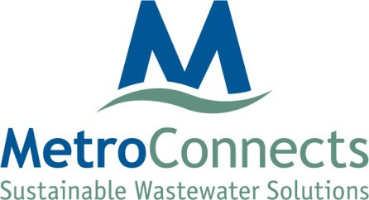

ReWa and MetroConnects

Sustaining Relationships Luncheon

August 16, 2023
11:30 a.m.

Location: 120 Augusta Arbor Way, Greenville, SC 29605

AGENDA

- Welcome and Introductions
- Lunch
- Adjournment

METROPOLITAN SEWER SUBDISTRICT
120 AUGUSTA ARBOR WAY GREENVILLE SC 29605 TELEPHONE 864.277.4442 FAX 864.277.4272

