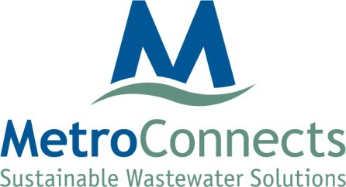

Operations Committee Meeting

APRIL 17, 2023
1:00 p.m.

Location: 120 Augusta Arbor Way, Greenville, SC 29605

AGENDA

- Public Meeting
  - Hazard Mitigation Plan
- Other

METROPOLITAN SEWER SUBDISTRICT
120 AUGUSTA ARBOR WAY GREENVILLE SC 29605 TELEPHONE 864.277.4442 FAX 864.277.4272

